Best secondary schools in London 2023
Friday December 09 2022, 6.00am, The Sunday Times

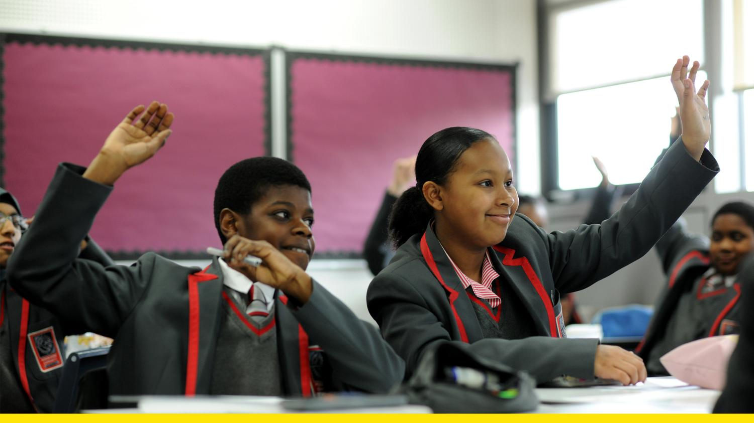
The capital leads the way, thanks to fierce competition, faith schools and an ambitious comp rethinking what inner-city, nonselective education can be
The dominance of London as an educational powerhouse continues, with half of the country’s top ten secondary schools in both state and fee-paying sectors located in the capital.
There is not just a postcode lottery at play, but a clever-clogs cachet. All the pupils at the top schools in both private and state sectors sit competitive entrance tests aged 11 or 13 to win a place. Many of the highest-performing schools in both sectors are also single-sex.
St Paul’s Girls’ School (SPGS) in west London, where 700 11-year-olds apply for 115 places, has topped the league tables for exam results in the fee-paying sector every year except one since 2011. The £27,792-a-year school — where the daughters of KCs, doctors and bankers compete to gain admission — has a reputation for turning out brilliant high-flyers. Its alumnae include the Labour politician Harriet Harman, the broadcaster Rachel Johnson and the actresses Jennifer Saunders and Rachel Weisz.
This summer 99.5 per cent of A-level papers taken by SPGS pupils were awarded A*-B, while 97.9 per cent of GCSEs were graded 9-7 or A*/A. An indication of the pressures on teenage girls was offered by Clarissa Farr, a former head teacher, who has spoken of revamping the dining service at the school and hiring a top chef to offer delicious meals in an attempt to tackle body image issues — a development since copied by other private schools.
The school says: “Public exams are important as students move on to university and beyond, but we treat these as a byproduct of the education we provide.” All pupils take a foundation course in coding and “creative technology” to prepare them for a world marked by “digital change” and there are dozens of clubs.
Recognising the importance of the girls’ mental health and the pressures on teenagers, the school last year set up a wellbeing centre. “Wellbeing sits at the very heart of fulfilment and academic success,” the school said. It offers five-day-a-week access to counselling, “with a daily drop-in slot for ad-hoc visitors”.
St Paul’s Girls’ is closely followed in the rankings by the nearby St Paul’s boys’ school, where 98.8 per cent of A-level papers were awarded A*-B.
It is notable that half of the top ten fee-paying schools are girls-only schools. They include the Godolphin and Latymer School in Hammersmith, where almost 900 girls apply for 120 places at the age of 11; Francis Holland, Sloane Square; City of London School for Girls; and North London Collegiate School.
In the state sector the top-performing schools are led once again by an all-girls school. The Henrietta Barnett School (HBS), a grammar in Hampstead, north London, heads the state rankings, followed in second place by Queen Elizabeth’s School, a boys’ grammar in Barnet. More than 3,000 11-year-olds sit entrance tests in maths and English for one of the 104 places on offer at HBS each year. Many of the successful candidates are of Indian or Sri Lankan heritage.

Clare Wagner, the head teacher, believes HBS’s strong showing at the top of the state tables this summer is partly down to their response to lockdowns in the pandemic. While pupils in some schools lacked laptops to study at home and teachers struggled to create online lessons, at HBS the switch to virtual learning was swift and smooth.
“The teachers made the lessons good, the girls logged in [via the Google Cloud Platform] and submitted their work on time and parents supported them to study at home. That is the magic triangle that produces good results: pupils, teachers, parents working together,” she says.
On top of excellent A-level and GCSE results, the school last year got 28 pupils into Oxbridge — one in five of the sixth form. Maths and physics are particularly strong subjects.
However, the school was recently downgraded from “outstanding” to “good” by the schools inspectorate Ofsted, a judgment Wagner says the school formally appealed. “I said, how can you say that a sixth form that gets that kind of A-level results and Oxbridge success is only ‘good’?” HBS is opening a health and wellbeing centre for the girls this year as part of its improvement plans.
The highest-performing comprehensive school in the capital is The Coopers’ Company and Coborn School in Upminster, known as the East End Hogwarts. The school, which selects 10 per cent of its year 7 intake on aptitude for sport or music, has leapt from 208th= in the national rankings to 77th.
Sue Hay, the head teacher, says that the school — motto “Love as brethren” — is more than a school or an exam factory: it is a family. She credits the dedication of her staff for its success.
On their return after lockdown, year 11 pupils were given another motto: “Level up and power up.” Motivational workshops, leaderboards, prizes and continuous and targeted assessment helped those taking exams, especially year 13 students facing their first foray into high-stakes exams. The measures played a strong role in improving exam results, Hay believes.
“The school stayed open every day in lockdown and I was in every day,” she says. “We were overjoyed with the results, but we’re not a factory. It is about building motivation and resilience through extracurricular activities.”
Mossbourne Community Academy is commended as the highest-achieving nonselective comprehensive in London. Its results have led to it jumping from 252nd= in the national rankings in pre-pandemic 2019 to 120th.
The school, which is surrounded by council estates in Hackney, east London — one of the poorest parts of the capital and an area where drugs gangs operate — was one of the country’s first academies, opening its doors in 2004. Mossbourne became one of the first state schools to send more than a dozen teenagers in a single year to Oxford and Cambridge universities, setting out to “reimagine what inner-city, nonselective education could be”, as its website puts it.
Renowned for strict discipline and high expectations of pupils, who wear a grey and red uniform with blazer and tie, the school has huge range of clubs in the evening at the school, which stays open into the evening, and even a rowing academy.

